Digital Nurture 4.0 – Week 3
Spring data jpa

1: spring-data-jpa-handson
Create a new schema named “ormlearn” in the local MySQL Workbench.Then update application.properties in the src/main/resources directory.

PROGRAM
application.properties:
logging.level.org.springframework=info
logging.level.com.cognizant=debug
logging.level.org.hibernate.SQL=trace
logging.level.org.hibernate.type.descriptor.sql=trace
logging.pattern.console=%d{dd-MM-yy} %d{HH:mm:ss.SSS} %-20.20thread %5p %-25.25logger{25} %25M %4L %m%nspring.datasource.driver-class-name=com.mysql.cj.jdbc.Driver
pring.datasource.url=jdbc:mysql://localhost:3306/ormlearn
spring.datasource.username=root
spring.datasource.password=root@123
spring.jpa.hibernate.ddl-auto=validate
spring.jpa.properties.hibernate.dialect=org.hibernate.dialect.MySQL5Dialect
use ormlearn;
create table country (
co_code varchar(2) primary key,
co_name varchar(50)
);
insert into country values ('IN', 'India');
insert into country values ('US', 'United States of America');
Create a class named Country.java in the src/main/java/com/cognizant/ormlearn/model directory.
Country.java
package com.cognizant.ormlearn.model;
import javax.persistence.Column;
import javax.persistence.Entity;
import javax.persistence.Id;
import javax.persistence.Table;

@Entity
@Table(name = "country")
public class Country {
@Id
@Column(name = "co_code")
private String code;
@Column(name = "co_name")
private String name;
public String getCode() {
return code;
}
public void setCode(String code) {
this.code = code;
}
public String getName() {
return name;
}
public void setName(String name) {
this.name = name;
}
@Override
public String toString() {
return "Country [code=" + code + ", name=" + name + "]";
}
}
CountryRepository.java
package com.cognizant.ormlearn.repository;
import org.springframework.data.jpa.repository.JpaRepository;
import org.springframework.stereotype.Repository;
import com.cognizant.ormlearn.model.Country;
@Repository
public interface CountryRepository extends JpaRepository<Country, String> {
}

CountryService.java:
package com.cognizant.ormlearn.service;
import java.util.List;
import org.springframework.beans.factory.annotation.Autowired;
import org.springframework.stereotype.Service;
import org.springframework.transaction.annotation.Transactional;
import com.cognizant.ormlearn.model.Country;
import com.cognizant.ormlearn.repository.CountryRepository;

@Service
public class CountryService {
@Autowired
private CountryRepository countryRepository;

@Transactional
public List<Country> getAllCountries() {
return countryRepository.findAll();
}
}

OrmlearnApplication.java:
package com.cognizant.ormlearn;
import java.util.List;
import org.slf4j.Logger;
import org.slf4j.LoggerFactory;
import org.springframework.boot.SpringApplication;
import org.springframework.boot.autoconfigure.SpringBootApplication;
import org.springframework.context.ApplicationContext;
import com.cognizant.ormlearn.model.Country;
import com.cognizant.ormlearn.service.CountryService;

@SpringBootApplication
public class OrmLearnApplication {

private static final Logger LOGGER = LoggerFactory.getLogger(OrmLearnApplication.class);
private static CountryService countryService;
public static void main(String[] args) {
ApplicationContext context = SpringApplication.run(OrmLearnApplication.class, args);
LOGGER.info("Inside main");
countryService = context.getBean(CountryService.class);
testGetAllCountries();
}

private static void testGetAllCountries() {
LOGGER.info("Start");
List<Country> countries = countryService.getAllCountries();
LOGGER.debug("countries={}", countries);
LOGGER.info("End");
}
}

OUTPUT

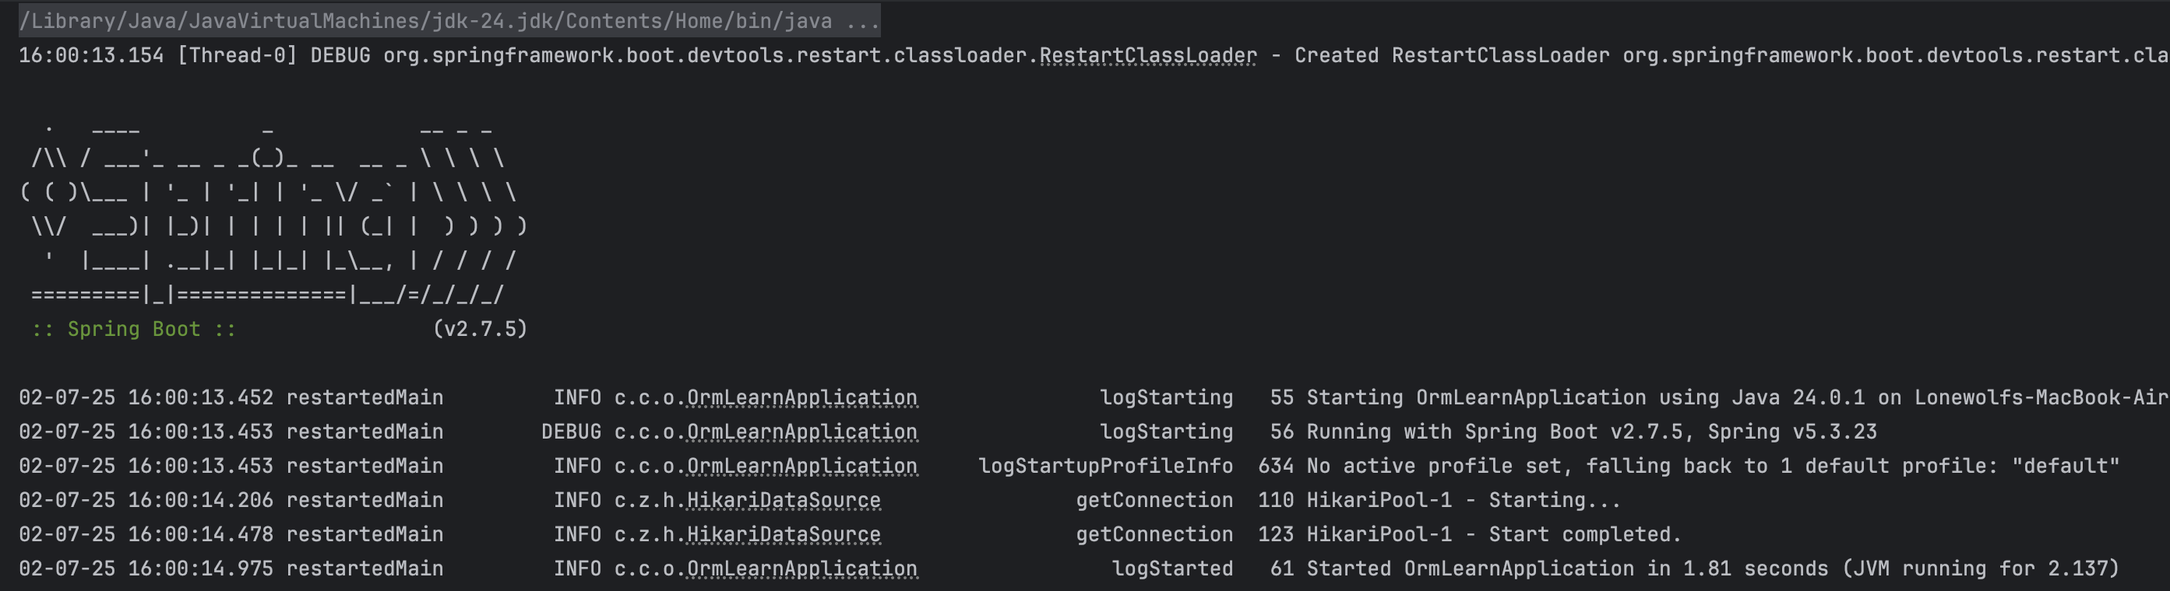

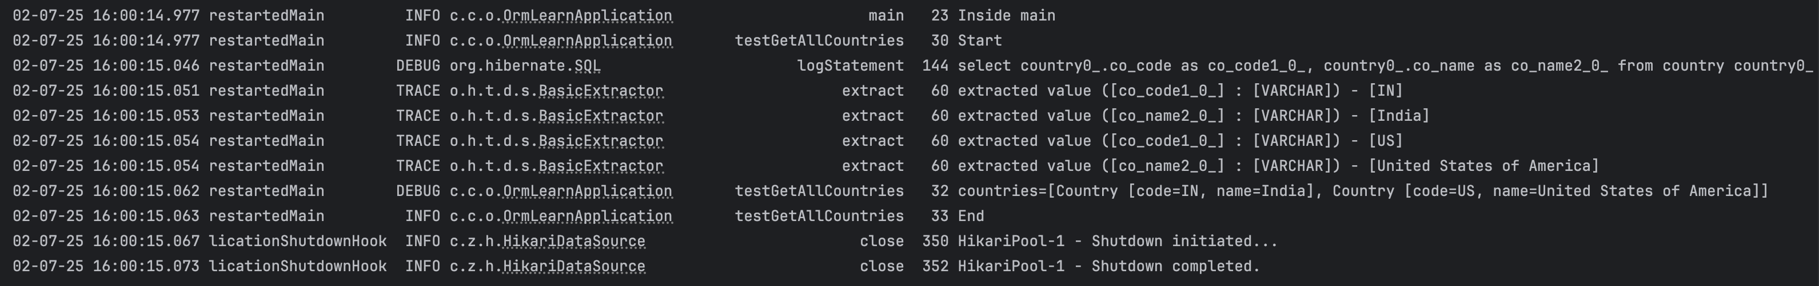

4 : Difference between JPA, Hibernate and Spring Data JPA:
Hibernate implentation:
Create a project named hibernate-example.Then configure pom.xml.
PROGRAM
pom.xml
<project xmlns="http://maven.apache.org/POM/4.0.0"
xmlns:xsi="http://www.w3.org/2001/XMLSchema-instance"
xsi:schemaLocation="http://maven.apache.org/POM/4.0.0
http://maven.apache.org/xsd/maven-4.0.0.xsd">
<modelVersion>4.0.0</modelVersion>
<groupId>com.example</groupId>
<artifactId>hibernate-example</artifactId>
<version>1.0</version>

<dependencies>
<dependency>
<groupId>org.hibernate</groupId>
<artifactId>hibernate-core</artifactId>
<version>6.4.4.Final</version>
</dependency>
<dependency>
<groupId>com.mysql</groupId>
<artifactId>mysql-connector-j</artifactId>
<version>8.3.0</version>
</dependency>
<dependency>
<groupId>jakarta.persistence</groupId>
<artifactId>jakarta.persistence-api</artifactId>
<version>3.1.0</version>
</dependency>
</dependencies>
</project>
hibernate.cfg.xml
<?xml version='1.0' encoding='utf-8'?>
<!DOCTYPE hibernate-configuration PUBLIC
"-//Hibernate/Hibernate Configuration DTD 3.0//EN"
"http://www.hibernate.org/dtd/hibernate-configuration-3.0.dtd">
<hibernate-configuration>
<session-factory>
<property name="hibernate.connection.driver_class">com.mysql.cj.jdbc.Driver</property>
<property name="hibernate.connection.url">jdbc:mysql://localhost:3306/test1</property>
<property name="hibernate.connection.username">root</property>
<property name="hibernate.connection.password">root@123</property>
<property name="hibernate.dialect">org.hibernate.dialect.MySQLDialect</property>
<property name="hibernate.hbm2ddl.auto">update</property>
<property name="show_sql">true</property>

<mapping class="com.example.hibernate.Employee"/>
</session-factory>
</hibernate-configuration>

Employee.java
package com.example.hibernate;
import jakarta.persistence.*;

@Entity
@Table(name = "employees")
public class Employee {

@Id
@GeneratedValue(strategy = GenerationType.IDENTITY)
private Integer id;

private String name;
private String department;

public Employee() {}

public Employee(String name, String department) {
this.name = name;
this.department = department;
}

public Integer getId() { return id; }
public void setId(Integer id) { this.id = id; }

public String getName() { return name; }
public void setName(String name) { this.name = name; }

public String getDepartment() { return department; }
public void setDepartment(String department) { this.department = department; }
}

EmployeeDad.java
package com.example.hibernate;
import org.hibernate.*;
import org.hibernate.cfg.Configuration;

public class EmployeeDAO {
private static SessionFactory factory;

static {
factory = new Configuration().configure()
.addAnnotatedClass(Employee.class)
.buildSessionFactory();
}

public Integer addEmployee(Employee employee) {
Session session = factory.openSession();
Transaction tx = null;
Integer employeeID = null;

try {
tx = session.beginTransaction();
employeeID = (Integer) session.save(employee);
tx.commit();
} catch (Exception e) {
if (tx != null) tx.rollback();
e.printStackTrace();
} finally {
session.close();
}
return employeeID;
}

public void close() {
factory.close();
}
}

App.java
package com.example.hibernate;

public class App {
public static void main(String[] args) {
EmployeeDAO dao = new EmployeeDAO();

Employee emp = new Employee("Alice", "Engineering");
Integer id = dao.addEmployee(emp);

System.out.println("Employee created with ID: " + id);

dao.close();
}
}

OUTPUT

Configuring Spring JPA implengtation:
Configuring configure spring intializr by using below table deatils
Now open it on eclipse idle.In com/example/employeeapp create the classes named Employee.java,EmployeeRepository.java,EmployeeService.java, and EmployeeController.java.

Employee.java
package com.example.employeeapp;
import jakarta.persistence.*;

@Entity
public class Employee {
@Id
@GeneratedValue(strategy = GenerationType.IDENTITY)
private Integer id;
private String name;
private String department;
public Employee() {}

public Employee(String name, String department) {
this.name = name;
this.department = department;
}

public Integer getId() { return id; }
public void setId(Integer id) { this.id = id; }

public String getName() { return name; }
public void setName(String name) { this.name = name; }

public String getDepartment() { return department; }
public void setDepartment(String department) { this.department = department; }
}

EmployeeRepository.java:(Interface)
package com.example.employeeapp;
import org.springframework.data.jpa.repository.JpaRepository;

public interface EmployeeRepository extends JpaRepository<Employee, Integer> {
}

EmployeeService.java:
package com.example.employeeapp;

import org.springframework.beans.factory.annotation.Autowired;
import org.springframework.stereotype.Service;
import org.springframework.transaction.annotation.Transactional;

@Service
public class EmployeeService {
@Autowired
private EmployeeRepository employeeRepository;

@Transactional
public Employee addEmployee(Employee employee) {
return employeeRepository.save(employee);
}
}

EmployeeController.java:
package com.example.employeeapp;

import org.springframework.beans.factory.annotation.Autowired;
import org.springframework.web.bind.annotation.*;

@RestController
@RequestMapping("/employees")
public class EmployeeController {
@Autowired
private EmployeeService employeeService;

@PostMapping
public Employee createEmployee(@RequestBody Employee employee) {
return employeeService.addEmployee(employee);
}
}

application.properties:
spring.datasource.url=jdbc:mysql://localhost:3306/test2
spring.datasource.username=root
spring.datasource.password=root@123
spring.jpa.hibernate.ddl-auto=update
spring.jpa.show-sql=true

Create scheme called test2 on your MySQL Database.And ensure the username and password

OUTPUT

